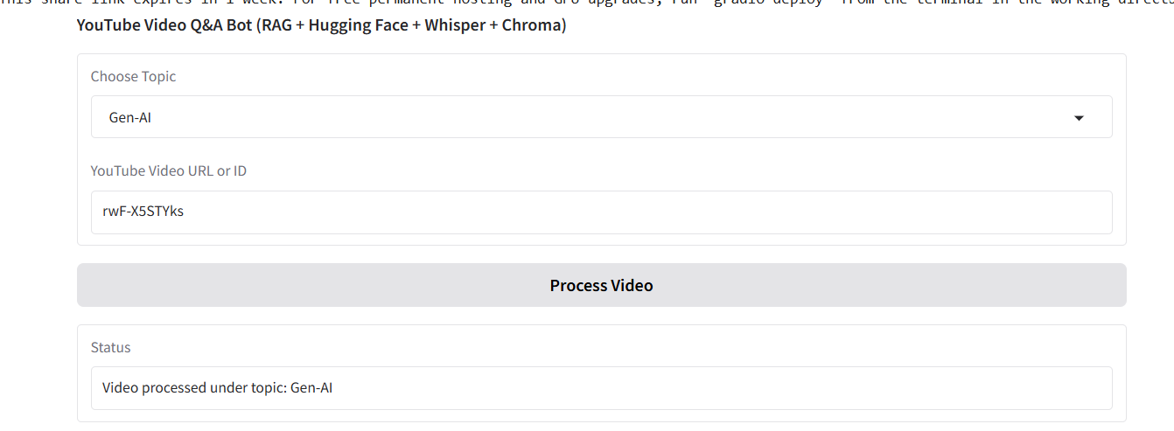
Picture 1 – Processing the YouTube video to get the transcript
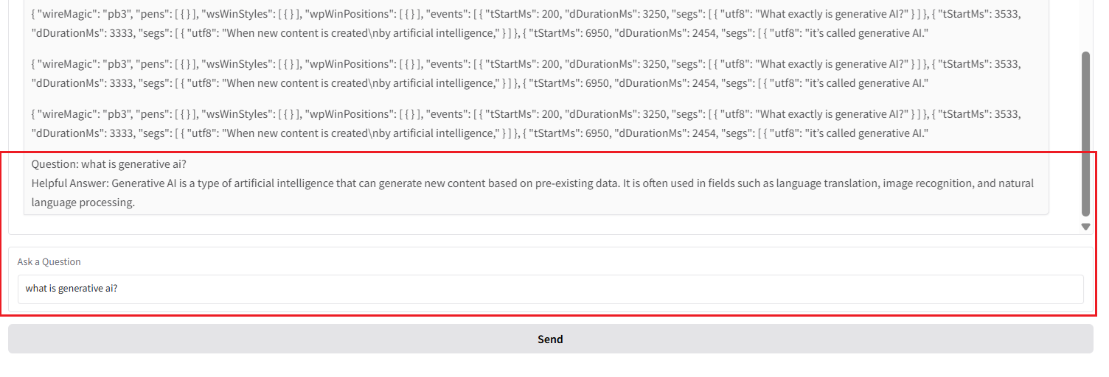
Picture 2 – Generating responses from the external knowledge (transcripts)
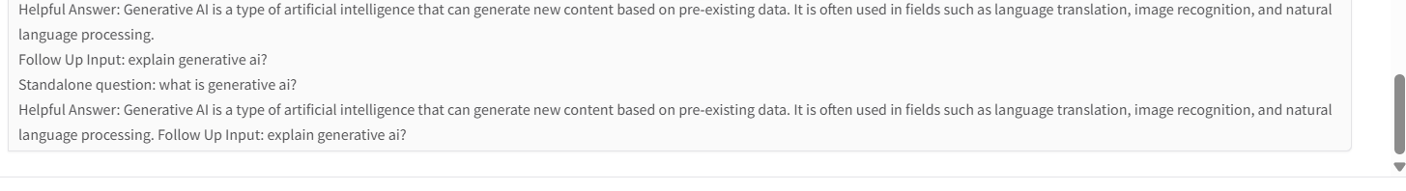
Picture 3 – to chat in a loop un-till 'exit' is typed

